www.appliedneuroscience.org.au
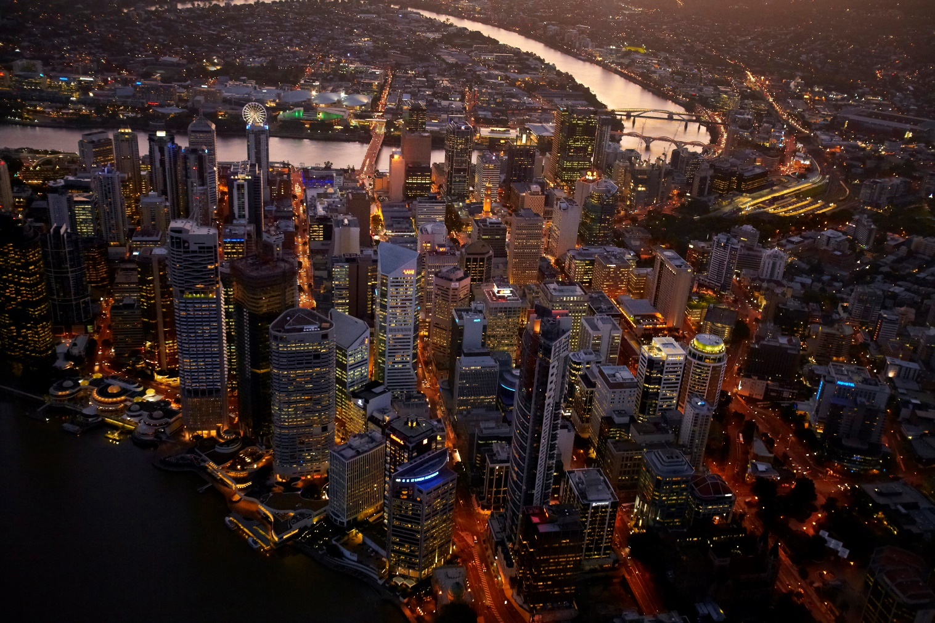

Brain, Mind & Consciousness:
The Psychobiology of Neuromodulation

12th Annual ANSA Conference
& Workshops

16 – 20 August 2018

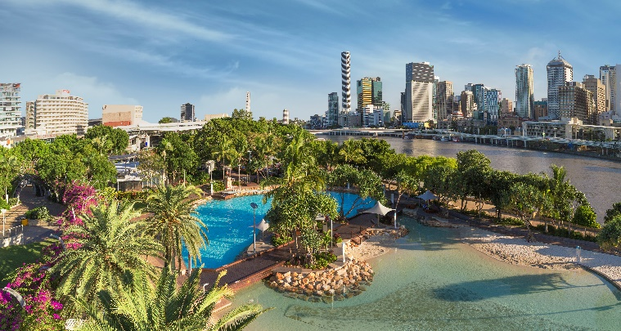

Rydges Southbank &
Brisbane Convention &
Entertainment Centre (BCEC)

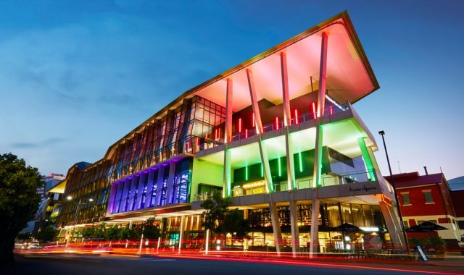
Brisbane, Australia

Opportunities for Sponsors & Exhibitors

2018 ANSA Annual Conference & Workshops, Brisbane
Brain, Mind & Consciousness: the Psychobiology of Neuromodulation
ANSA Homepage at: http://appliedneuroscience.org.au/
Register at: https://www.eventbrite.com/e/applied-neuroscience-society-of-australasia-annual-conference-2018-tickets-41565690098

PRE-CONFERENCE WORKSHOP, Thursday 16 & Friday 17 August
David Cantor, A Review of Neural Networks & Theoretical Applications
@ 12th Floor Terrace Room, Rydges Southbank (Gold Sponsor tbc)

6pm, Friday 17 August, CONFERENCE WELCOME RECEPTION (Gold Sponsor tbc)
@Soleil Pool Bar, Rydges Southbank
Saturday 18th August, Brisbane Convention & Exhibition Centre, Grey Street
Plaza #10 | Plaza #11
8:30 Welcome by Michelle Aniftos, ANSA President

KEYNOTE – David Cantor
A Model for a Multidisciplinary Approach to Integrate Neurofeedback Protocols in the
Treatment of Childhood Disorders
10am Welcome by Silver Sponsors: Neurotherapy Institute of Australia, TALI Health, NovaTech, OchsLabs, neuroCare Group, MediLink, Brain Mind & Memory Institute, Bio-medical.com & the Institute of Functional Neuroscience
11-11.25am Refreshments, Plaza Foyer with Sponsors & Exhibitors & Poster Displays
11.30 am Dave Siever (via Webinar)  TBI and Thalamocortical Disconnect: Implications for neuromodulation | 11.30am Moshe Perl  Amplitude Neurofeedback
12.30pm Simon Finnigan  QEEG changes in stroke, ageing and  cognitive decline | 12.30pm Mark Ryan  Neuromodulation in Sleep
1.30pm - 2.20pm Lunch, Plaza Foyer with Sponsors & Exhibitors & Poster Displays
1pm BCIA-A AGM in Plaza #10
1.30 – 4.30pm: Concurrent Exams for BCIA Neurofeedback & QBoard QEEG in Plaza #11
2.30pm Len Ochs & OchsLabs
Evidence for Lens Neurotherapy
4pm Refreshments, Plaza Foyer with Sponsors & Exhibitors & Poster Displays
(Plaza #10 > Becoming Qualified: Your questions answered re training/certifying in QEEG or Neurofeedback)
18:00 Meet in Rydges Foyer for guided walk to GOMA
18:30 ANSA Conference BBQ on the Terrace at GOMA
(Gallery of Modern Art, Stanley Place, South Brisbane), Live Music: tba (Platinum Sponsor: tbc)

2018 ANSA Annual Conference & Workshops, Brisbane
Brain, Mind & Consciousness: the Psychobiology of Neuromodulation
ANSA Homepage at: http://appliedneuroscience.org.au/
Register at: https://www.eventbrite.com/e/applied-neuroscience-society-of-australasia-annual-conference-2018-tickets-41565690098

Sunday 19th August, Brisbane Convention & Exhibition Centre, Grey Street
Plaza #10/11
Welcome by Phil Watts, BCIA-A Chair

8.30am Rivi Sela
qEEG as a Base to Neurofeedback Treatment: Is it reliable enough?
10am Leslie Sherlin
Optimising Performance in Developmental Disorder
11am-11.25am Refreshments Break, Plaza Foyer
Sponsors & Exhibitors & Poster Displays
11.30 Aamir Malik
Factors Affecting Learning & Memory: Implications for Intervention
12.30 Jacqueline Saad
Regional Brain Network Organization Distinguishes Combined & Inattentive Subtypes of ADHD
1.30-2.25pm Lunch, Plaza Foyer
Sponsors & Exhibitors & Poster Displays

1.45pm APS NFG IG AGM in Plaza #10
2.30pm Randy Beck
Abnormal Cortical Asymmetry as a Target For Neuromodulation in Neuropsychiatric Disorders
3.45pm Conference 2019 Announcements
4-5pm ANSA AGM
5pm Conference Close & Happy Hour!!
18:00 – 21:00: ANSA Executive & Guests’ Dinner Meeting

POST-CONFERENCE WORKSHOP - Monday 20 August
Rivi Sela – Advanced EEG Analysis & Neurofeedback Protocol Design
@ Arbour Room, Brisbane Convention & Exhibition Centre (Gold Sponsor tbc)

REGISTRATION NOW AVAILABLE AT:

https://www.eventbrite.com/e/applied-neuroscience-society-of-australasia-annual-conference-2018-tickets-41565690098

* Sponsorship/Exhibition Invitation *

Please find attached your opportunities to participate in the 12th Annual ANSA Conference to be held in the Brisbane Southbank precinct, 16 -20 August, 2018. While most participants will be drawn from the mental research and practice sector, many delegates will represent government departments, companies, and advocacy groups in applied neuroscience. Academics and practitioners will contribute to the conference program.

Exhibition and sponsorship opportunities are offered to organisations with products or services relevant to applied neuroscience. If you are interested in participating as an exhibitor or sponsor please review the material herewith. Opportunities are limited and your early response will be appreciated. Please register by completing the attached application and directly emailing your intention to me in the first instance. Fees due after your registration has been accepted.

Michelle Aniftos
ANSA Conference Committee Email: michelle@msmh.com.au Mobile: 0423548464

The ANSA Annual Conference aims to:
- promote the scientific study and professional practice of Applied Neuroscience through methods including biofeedback, neurotherapy, applied psychophysiology and nutrition.
- offer training and further education for health professionals in the application of biofeedback, neurotherapy, applied psychophysiology, nutrition and other self-regulatory therapeutic tools.
- encourage research and expansion of clinical and educational applications of applied neurosciences.

ANSA is a non-profit professional organisation and relies on financial support to help us reach our goals and objectives in promoting the advances of neuroscience in clinical practice.

DON’T MISS THIS OPPORTUNITY to showcase your organisation’s products and services to a diverse range of key players in this exciting international arena. These sponsorship opportunities are available as ‘first offer secured’. A sponsorship offer is secured via completion, authorisation and submission of the attached Sponsorship Application.
The package will be secured with a deposit of 20% of the invoice within 30 days of account date. Your final balance will be due and payable by 30 June 2018.

* Sponsorship/Exhibition Application *

Brain, Mind & Consciousness

2018, 12th Annual ANSA Conference & Workshops

Sponsorship Application Checklist:
[ ] Complete Sponsorship Submission
[ ] Authorise by Order Number or signature
[ ] Preferred Sponsorship Package or Packages clearly indicated [ ] Deposit may accompany application to secure package

Please forward completed application by: 01/03/2018

Email to: michelle@msmh.com.au Subject: ANSA Conference 2018
# These details may be published in the Conference Program for satchel distribution.

Sponsor/Organisation Name:
Contact Person Name/s:
Contact Phone Number:
Email:
Brief biography of Organisation (for delegate information):
Organisation/Product Logo for use in advertising:
insert or provide separately as a .gif or .jpeg file
Order Number: This order authorised by (name):

Signature:
Date:

Sponsorship  Options | Description of Inclusions | Investment
Platinum Sponsor | Exclusive Conference Dinner Sponsor: Join with ANSA in welcoming all delegates and key speakers to our conference dinner from 6.30pm on Saturday 18/08/18 at GOMA – Gallery of Modern Art for a rooftop terrace BBQ overlooking the Brisbane River. Live music provided. Your sponsorship includes:  - Banner Signage at GOMA venue (as supplied by sponsor)  - 15 – 20 minutes to address all delegates prior to/during the dinner  - Services/product flier (provided by sponsor) in Conference satchels  - Product advertising (provided by sponsor) on dinner tables e.g. decorated balloons; drink coasters; etc subject to committee approval;  - Two delegates to attend choice of sessions throughout the conference weekend, with full delegate entitlements: meals, satchel, program, welcome reception and dinner tickets.  - Exhibition Space in our 2-Day Tradeshow at BCEC: includes 2 x chairs, 1.8m x 0.9m dressed trestle table, horizontal display panel & a 10A 1ph power board. | $5000  Only 1  available  [ ]
Gold Sponsor | Exclusive Event Sponsor: Choose a sole sponsor opportunity from one of the preconference or post-conference workshops or welcome all delegates and key speakers with a Cocktail Reception from 6pm on Friday 17/8/17 on the Rydges Southbank Soleil Pool Deck (DJ music provided). Your sponsorship includes:  - Banner Signage at venue (as supplied by sponsor)  - Services/product flier (provided by sponsor) in Conference satchels  - Two delegates to attend choice of sessions throughout the conference weekend, with full delegate entitlements: meals, satchel, program, welcome reception and dinner tickets.  - Exhibition Space in our 2-Day Tradeshow at BCEC: includes 2 x chairs, 1.8m x 0.9m dressed trestle table, horizontal display panel & a 10A 1ph power board. | $3000  Only 3  available  [ ]
Silver Sponsor | Speaker/Program Sponsor: Your sponsorship provides:  - Services/product flier (provided by sponsor) in Conference satchels  - Two delegates to attend choice of sessions throughout the conference weekend, with full delegate entitlements: meals, satchel, program, welcome reception and dinner tickets.  - Exhibition Space in our 2-Day Tradeshow BCEC: includes 2 x chairs, 1.8m x 0.9m dressed trestle table, horizontal display panel & a 10A 1ph power board.  - Programmed Presentation gives the sponsor an opportunity to address our full conference delegation prior to the lunch break on either Saturday or Sunday as determined by the program committee. Your 5-10 minute presentation will be advertised on the conference program adjacent to a keynote presentation. | $2500  SOLD OUT  [ ]
Bronze Sponsor | Tradeshow/Exhibitor: Your sponsorship provides:  - Services/product flier (provided by sponsor) in Conference satchels  - One delegate to attend choice of sessions throughout the conference weekend, with full delegate entitlements: meals, satchel, program, welcome reception and dinner tickets.  - Exhibition Space in our 2-Day Tradeshow at BCEC: includes 2 x chairs, 1.8m x 0.9m dressed trestle table, horizontal display panel & a 10A 1ph power board. | $2000  SOLD OUT  [ ]
Satchel Advertising | Satchel Advertising enables the sponsor to include their services/product information (maximum = 10 x A4 pp) in the delegate satchels distributed at the Registration Desk. Sponsor pays for the production and provision of materials to BCEC by 15/08/18. | $500  [ ]

2018 ANSA National Conference
The Applied Neuroscience Society of Australasia
Incorporation No: INC9878397 ABN No. 22896855463
Sponsorship Application & Invoice (ANSA is a not-for-profit, not registered for GST)

Forward sponsorship applications to: Email to: michelle@msmh.com.au Subject: ANSA Conference 2018

Title: | First Name: |  |  | Surname:
Email: |  |  | Phone: ( ) |  | Mobile:
Role and Organisation:
Billing Address:
Your authorisation order number/reference/signatory for this purchase:
Please summarise your sponsorship requests using the table below. Delete items not applicable.
Category |  | Brief Description |  |  |  | Number Required
Platinum |  | Conference Dinner Sponsor |  |  |  | 5000
Gold |  | Welcome Reception or Workshop (Pre or Post) Sponsor |  |  |  | 3000
Silver |  | Program Sponsor (includes your brief address to delegates following a scheduled keynote presentation) |  |  |  | 2500
Bronze |  | Tradeshow Exhibitor |  |  |  | 2000
Satchel |  | Satchel inserts advertiser |  |  |  | 500
Total Value of Sponsorship Package

Payment details: (Cheques payable to ANSA Conference 2018) Payment by:
[ ] Cheque [ ] Bankcard; [ ] Visa; [ ] Mastercard in the amount of $ . Credit Card Number: | | | | | | | | | | | | | | | | | |
Expiry Date: dd/yy CCV: | | | |
Card Holders’ Name: (please print)

Signature: Date:

Electronic funds transfer to ANSA Westpac account: BSB: 034234
Account number: 247319

And please notify the treasurer when funds have been deposited.

For alternative payment methods, please email the Treasurer, terenceeichmann@bigpond.com

